**Department of Science and Humanities**

F Y B Tech SEM II 2021-22

Engineering Physics Lab Course

**Photoelectric Effect**

**Name: Pargat Singh**

**Roll No: 16010121045**

**Date: 13 April 2022**

**Batch: A2**

**Aim:** To understand the phenomenon of Photoelectric effect as a whole.

To plot a graph connecting photocurrent and applied

potential for (i) varying intensity; (ii) varying

wavelength/frequency.

To draw stopping potential as a function of frequency

of incident radiation to determine the Planck's constant

(home assignment)

**Apparatus:** Ammeter, Voltmeter, Light meter, Photodiode, Phototransistor

**Observation Table:**

Material: Copper

Area of plates: 0.5 cm2

**TABLE I: Fixed wavelength, varying intensity:**

|  |  |  |  |  |  |
| --- | --- | --- | --- | --- | --- |
| Wavelength: 150 nm | | | | | |
| Intensity = 15 W/m2 | | Intensity = 20 W/m2 | | Intensity = 25 W/m2 | |
| Voltage (V) | Current (µA) | Voltage (V) | Current (µA) | Voltage (V) | Current (µA) |
| 0 | 26.83 | 0 | 35.77 | 0 | 44.71 |
| -0.4 | 23.83 | -0.4 | 31.77 | -0.4 | 39.71 |
| -0.8 | 20.83 | -0.8 | 27.77 | -0.8 | 34.71 |
| -1.2 | 17.83 | -1.2 | 23.77 | -1.2 | 29.71 |
| -1.6 | 14.83 | -1.6 | 19.77 | -1.6 | 24.71 |
| -2.0 | 11.83 | -2.0 | 15.77 | -2.0 | 19.71 |
| -2.4 | 8.83 | -2.4 | 11.77 | -2.4 | 14.71 |
| -2.8 | 5.83 | -2.8 | 7.77 | -2.8 | 9.71 |
| -3.2 | 2.83 | -3.2 | 3.77 | -3.2 | 4.71 |
| -3.6 | 0 | -3.6 | 0 | -3.6 | 0 |
| VS =-3.6 | 0 | VS =-3.6 | 0 | VS =-3.6 | 0 |

VS: Stopping potential

**TABLE II: Fixed intensity, varying wavelength:**

|  |  |  |  |  |  |
| --- | --- | --- | --- | --- | --- |
| Intensity: 30 W/m2 | | | | | |
| Wavelength = 100 nm | | Wavelength = 150 nm | | Wavelength = 200 nm | |
| Voltage (V) | Current (µA) | Voltage (V) | Current (µA) | Voltage (V) | Current (µA) |
| 0 | 115.74 | 0 | 53.66 | 0 | 22.62 |
| -0.9 | 102.24 | -0.4 | 47.66 | -0.2 | 19.62 |
| -1.8 | 88.74 | -0.8 | 41.66 | -0.4 | 16.62 |
| -2.7 | 75.24 | -1.2 | 35.66 | -0.6 | 13.62 |
| -3.6 | 61.74 | -1.6 | 29.66 | -0.8 | 10.62 |
| -4.5 | 48.24 | -2.0 | 23.66 | -1.0 | 7.62 |
| -5.4 | 34.74 | -2.4 | 17.66 | -1.2 | 4.62 |
| -6.3 | 21.24 | -2.8 | 11.66 | -1.4 | 1.62 |
| -7.2 | 7.74 | -3.2 | 5.66 | -1.6 | 0 |
| VS =-7.8 | 0 | VS =-3.6 | 0 | VS =-1.6 | 0 |

**Graphs:**

1. Voltage (X-axis) v/s current (Y-axis) for different intensities.

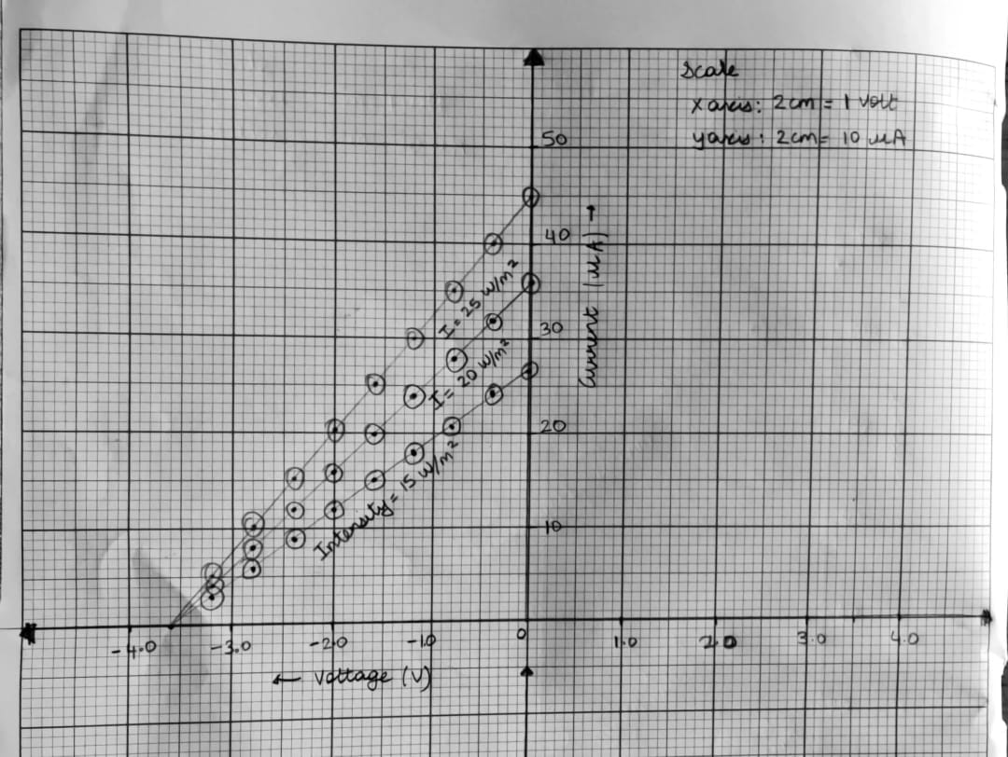

1. Voltage (X-axis) v/s current (Y-axis) for different wavelengths.

**Home Assignment:**

Plot graph of KE v/s frequency. From this graph, determine the following: cut-off wavelength, work function of the material of photocell and Planck’s constant.

1. λ =100nm x 1m/1 x 109nm = 1 x 10-7 m

c = f λ

⸫ f = c/ λ

So, f = 3 x 108 m/s = **3 x 1015 Hz**

1 x 10-7 m

1. λ =150nm x 1m/1 x 109nm = 1.5 x 10-7 m

c = f λ

⸫ f = c/ λ

So, f = 3 x 108 m/s = **2 x 1015 Hz**

1.5 x 10-7 m

1. λ =200nm x 1m/1 x 109nm = 2 x 10-7 m

c = f λ

⸫ f = c/ λ

So, f = 3 x 108 m/s = **1.5 x 1015 Hz**

2 x 10-7 m

|  |  |  |  |
| --- | --- | --- | --- |
| **λ (nm)** | 100 | 150 | 200 |
| **F(1013 Hz)** | 3 x 1015 Hz | 2 x 1015 Hz | 1.5 x 1015 Hz |
| **U(V)** | 7.8 | 3.6 | 1.6 |
| **Ek (ev)** | 7.8 | 3.6 | 1.6 |

We know that, h = Δ Ek / Δf = Δy/ Δx (slope)

h = (7.8 ev – 1.6 ev) x 1.6 x 10-19  J

1Ev

3 x 1015 Hz – 1.50 x 1015 Hz

h ~ 6.61 x 10-34 Js Work Function=-4.1 ev Cut-off frequency= 2.73 x 10-7

